**INDEX**

|  |  |  |  |
| --- | --- | --- | --- |
| **SR.NO** | **DATE** | **LAB** | **PAGE NO** |
| 1 | 21/02/23 | Gradient Descent for Linear Regression | 3 |
| 2 | 28/02/23 | Gradient Descent for Logistic Regression | 7 |
| 3 | 07/03/23 | Boosting Algorithm | 9 |
| 4 | 14/03/23 | Random Forest | 12 |
| 5 | 21/03/23 | Stacking With Hard Voting | 14 |
| 6 | 28/03/23 | Stacking With Soft Voting | 17 |
| 7 | 04/04/23 | PCA | 20 |
| 8 | 04/04/23 | LDA | 22 |
| 9 | 04/04/23 | SVD | 25 |
| 10 | 11/04/23 | Artificial Neural Network | 27 |

|  |  |  |
| --- | --- | --- |
| **Date** | **Lab No** | **Problem** |
| **21/02/2023** | **1** | To calculate the gradients using cost function and perform gradient decent for linear regression |

**Code:**

import random

import pandas as pd

import matplotlib.pyplot as plt

import numpy as np

study_time=[]

score=[]

for i in range(1,100):

n1=random.randint(1,20)

n2=random.randint(30,100)

study_time.append(n1)

score.append(n2)

student_data=pd.DataFrame({'study_time':study_time,'score':score})

df=student_data

plt.scatter(df['study_time'],df['score'])

plt.show()

std_norm=df

df_norm=df

std_norm['study_time']=(std_norm['study_time'] -(std_norm['study_time']).mean())/std_norm['study_time'].std()

df_norm['study_time']=(df['study_time']-min(df['study_time']))/(max(df['study_time'])-min(df['study_time']))

#df_norm['study_time']=(df['study_time']-df['study_time'].mean())/(max(df['study_time'])-min(df['study_time']))

plt.scatter(df_norm['study_time'],df_norm['score'])

plt.show()

def loss_function(m,b,df):

total_error=0

for i in range(len(df)):

x=df.iloc[i][0]

y=df.iloc[i][1]

total_error+=(y-(m*x)+b)**2

return (total_error/2*len(df))

def gradient_descent(m_now,b_now,df,L):

n=len(df)

s1=0

s2=0

for i in range(n):

x=df.iloc[i][0]

y=df.iloc[i][1]

s1+=(((m*x)+b)-y)*x

s2+=(((m*x)+b)-y)

m_now-=L*s1*(1/n)

b_now-=L*s2*(1/n)

return m_now,b_now

loss=loss_function(0.5,1.5,df_norm)

m=0 ,b=0 ,L=0.0001

epochs=100

for i in range(epochs):

m,b=gradient_descent(m,b,df_norm,L)

loss=loss_function(m,b,df_norm)

print(m,b,loss)

plt.scatter(df_norm['study_time'],df_norm['score'])

test_x=[]

predicted=[(m*x)+b for x in df_norm['study_time']]

for i in range(80,100):

test_x.append(random.random())

plt.plot(list(range(80,100)),[(m*x)+b for x in list(range(80,100))])

print(predicted)

**Output:**

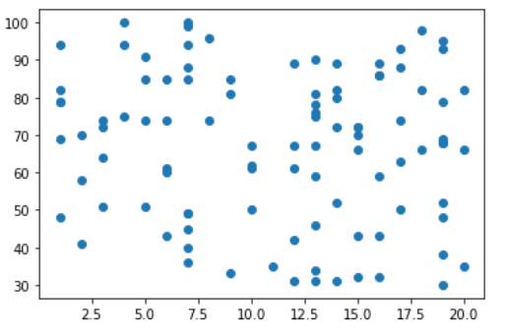

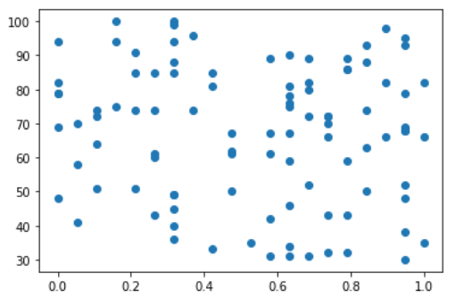

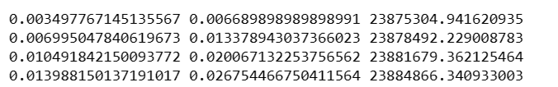

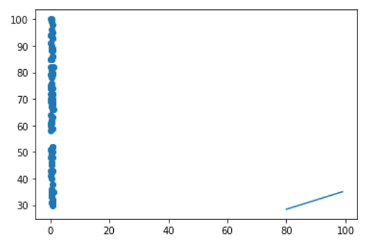

|  |  |  |
| --- | --- | --- |
| **Date** | **Lab No** | **Problem** |
| **28/02/2023** | **2** | To calculate the gradients using cost function and perform gradient decent for logisitc regression |

**Code:**

import numpy as np

from numpy import log,dot,exp,shape

import matplotlib.pyplot as plt

from sklearn.model_selection import train_test_split

from sklearn.datasets import make_classification

x,y = make_classification(n_features=4)

x_train,x_test,y_train,y_test = train_test_split(x,y,test_size=0.1,random_state=0)

class LogisticRegression:

def sigmoid(self,z):

sig = 1/(1+exp(-z)) return sig

def initialize(self,X):

weights = np.zeros((shape(X)[1]+1,1))

X = np.c_[np.ones((shape(X)[0],1)),X] return weights,X

def fit(self,X,y,alpha=0.001,iter=400):

weights,X = self.initialize(X)

def cost(theta):

z = dot(X,theta)

cost0 = y.T.dot(log(self.sigmoid(z)))

cost1 = (1-y).T.dot(log(1-self.sigmoid(z)))

cost = -((cost1 + cost0))/len(y)return cost

cost_list = np.zeros(iter,)

for i in range(iter):

weights = weights - alpha*dot(X.T,self.sigmoid(dot(X,weights))-np.reshape(y,(len(y),1)))

cost_list[i] = cost(weights)

self.weights = weights return cost_list

def predict(self,X):

z = dot(self.initialize(X)[1],self.weights)

lis = []

for i in self.sigmoid(z):

if i>0.5:

lis.append(1)

else:

lis.append(0) return lis

lgr = LogisticRegression()

model= lgr.fit(x_train,y_train)

y_pred = lgr.predict(x_test)

y_train = lgr.predict(x_train)

print(y_pred)

**Output:**



|  |  |  |
| --- | --- | --- |
| **Date** | **Lab No** | **Problem** |
| **07/03/2023** | **3** | To implement AdaBoost and XGBoost algorithms |

**Code:**

**1.AdaBoost**

import pandas as pd

from sklearn.ensemble import AdaBoostClassifier

from sklearn.tree import DecisionTreeClassifier

from sklearn.metrics import mean_squared_error, accuracy_score,confusion_matrix

from sklearn.model_selection import train_test_split

from sklearn.preprocessing import LabelEncoder

df=pd.read_csv("Fish.csv")

x=df.drop('Species',axis=1) y=df['Species']

le=LabelEncoder() y=le.fit_transform(y)

x_train,x_test,y_train,y_test=train_test_split(x,y,test_size=0.2,random_state=0)

ada = AdaBoostClassifier(base_estimator=DecisionTreeClassifier(max_depth=6),n_estimators=50,learning_rate=0.1)

ada.fit(x_train,y_train)

y_pred=ada.predict(x_test)

cm=confusion_matrix(y_pred,y_test)

accuracy = accuracy_score(y_test, y_pred)

pred=pd.DataFrame(data={'Y Test':list(y_test), 'Y Predicted':list(y_pred)})

print(pred)

print("Confusion Matrix: \n\n",cm) print("\n Accuracy:", accuracy)

**Output:**

**1.AdaBoost:**

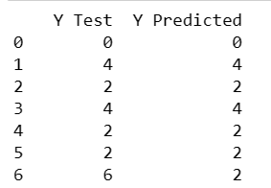

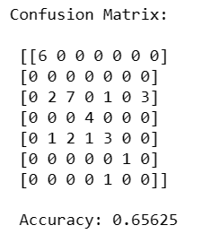

**2.XGBoost:**

import pandas as pd

import xgboost as xgb

from sklearn.metrics import accuracy_score

from sklearn.preprocessing import LabelEncoder

from sklearn.model_selection import train_test_split

from sklearn.metrics import confusion_matrix,accuracy_score

df=pd.read_csv("advertising.csv")

x=df.drop('Clicked on Ad',axis=1) y=df['Clicked on Ad']

le=LabelEncoder()

cols=["Ad Topic Line","City","Male","Country","Timestamp"]

for c in cols:

x[c]=le.fit_transform(x[c])

x_train,x_test,y_train,y_test=train_test_split(x,y,test_size=0.2,random_state=0)

xgb_model=xgb.XGBClassifier(learning_rate=0.1,max_depth=6,n_estimators=120)

xgb_model.fit(x_train,y_train)

y_pred=xgb_model.predict(x_test)

cm=confusion_matrix(y_pred,y_test)

pred=pd.DataFrame(data={'Y Test':list(y_test), 'Y Predicted':list(y_pred)})

print(pred) print("Confusion Matrix: \n\n",cm)

print("\nAccuracy: ",accuracy_score(y_test,y_pred))

**Output:**

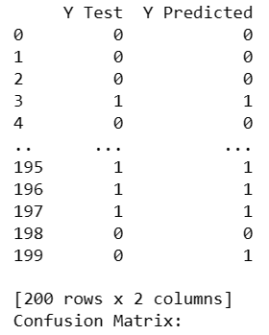

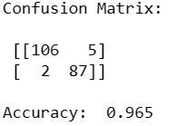

|  |  |  |
| --- | --- | --- |
| **Date** | **Lab No** | **Problem** |
| **14/03/2023** | **4** | To implement Random Forest in ensemble machine learning |

**Code:**

import random

import pandas as pd

import numpy as np

from sklearn.model_selection import train_test_split

from sklearn.ensemble import RandomForestClassifier

from sklearn.tree import DecisionTreeRegressor

from sklearn.linear_model import LinearRegression

from sklearn.metrics import accuracy_score,r2_score,confusion_matrix

from sklearn.preprocessing import LabelEncoder

from sklearn import datasets

titanic_data = pd.read_csv('https://web.stanford.edu/class/archive/cs/cs109/cs109.1166/stuff/titanic.csv')

X = titanic_data.drop('Survived', axis=1)

y = titanic_data['Survived']

columns=['Name','Sex']

for col in X.columns:

if(col in columns):

le=LabelEncoder()

X[col]=le.fit_transform(X[col])

train_X, test_X, train_y, test_y = train_test_split(X, y, test_size=0.2, random_state=42)

rf=RandomForestClassifier(n_estimators=100,max_depth=7)

rf.fit(x_train,y_train)

y_pred=rf.predict(x_test)

cm=confusion_matrix(y_pred,y_test)

accuracy = accuracy_score(y_test, y_pred)

pred=pd.DataFrame(data={'Y Test':list(y_test), 'Y Predicted':list(y_pred)})

print(pred)

print("Confusion Matrix: \n\n",cm)

print("\n Accuracy:", accuracy)

**Output:**

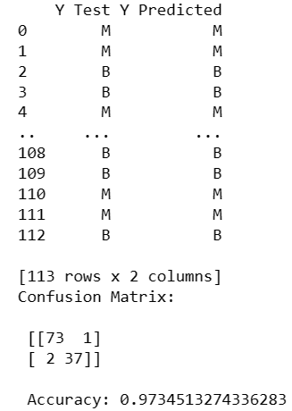

|  |  |  |
| --- | --- | --- |
| **Date** | **Lab No** | **Problem** |
| **21/03/2023** | **5** | To implement stacking model with hard voting method and interpret the performance measure |

**Code:**

from sklearn.datasets import load_iris

from sklearn.tree import DecisionTreeClassifier

from sklearn.linear_model import LogisticRegression

from sklearn.neighbors import KNeighborsClassifier

from sklearn.naive_bayes import GaussianNB

from sklearn.ensemble import RandomForestClassifier

from sklearn.model_selection import train_test_split

from sklearn.metrics import accuracy_score

import pandas as pd

# Load the Iris dataset

from sklearn.datasets import load_digits

X, y = load_digits(return_X_y=True)

# Split data into train and test sets

X_train, X_test, y_train, y_test = train_test_split(X, y, test_size=0.2, random_state=42)

# Define the base classifiers

clf1 = DecisionTreeClassifier(max_depth=2, random_state=42)

clf2 = LogisticRegression(random_state=42)

clf3 = GaussianNB()

clf4 = RandomForestClassifier(random_state=42)

# Train the base classifiers on the training data

clf1.fit(X_train, y_train)

clf2.fit(X_train, y_train)

clf3.fit(X_train, y_train)

clf4.fit(X_train, y_train)

# Make predictions on the test data using the base classifiers

y_pred1 = clf1.predict(X_test)

y_pred2 = clf2.predict(X_test)

y_pred3 = clf3.predict(X_test)

y_pred4 = clf4.predict(X_test)

# Combine the predictions of the base classifiers into a stacked dataset

stacked_data = []

for i in range(len(X_test)):

stacked_data.append([y_pred1[i], y_pred2[i]])

# Train a meta-classifier on the stacked dataset

meta_clf = DecisionTreeClassifier(max_depth=2, random_state=42)

meta_clf.fit(stacked_data, y_test)

# Make predictions on the test data using the meta-classifier

y_pred_meta = meta_clf.predict(stacked_data)

# Combine the predictions of the base classifiers and the meta-classifier using hard voting

y_pred = []

for i in range(len(X_test)):

votes = [y_pred1[i], y_pred2[i], y_pred_meta[i]]

y_pred.append(max(set(votes), key=votes.count))

# Print the accuracy score of the ensemble classifier

accuracy = accuracy_score(y_test, y_pred)

pred=pd.DataFrame(data={'Y Test':list(y_test), 'Y Predicted':list(y_pred)})

print(pred)

print("Ensemble accuracy:", accuracy)

**Output:**

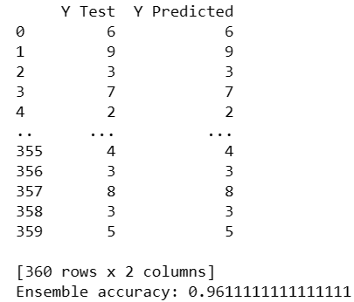

|  |  |  |
| --- | --- | --- |
| **Date** | **Lab No** | **Problem** |
| **28/02/2023** | **6** | To implement stacking model with soft voting method and interpret the performance measure |

**Code:**

from sklearn.datasets import load_digits

from sklearn.tree import DecisionTreeClassifier

from sklearn.neighbors import KNeighborsClassifier

from sklearn.naive_bayes import GaussianNB

from sklearn.ensemble import RandomForestClassifier

from sklearn.linear_model import LogisticRegression

from sklearn.model_selection import train_test_split

from sklearn.metrics import accuracy_score

import pandas as pd

import numpy as np

# Load the digits dataset

digits = load_digits()

# Split the data into training and testing sets

X_train, X_test, y_train, y_test = train_test_split(digits.data, digits.target, test_size=0.2, random_state=42)

# Define the base classifiers

clf1 = DecisionTreeClassifier(max_depth=2, random_state=42)

clf2 = KNeighborsClassifier(n_neighbors=5)

clf3 = GaussianNB()

clf4 = RandomForestClassifier(n_estimators=10, random_state=42)

# Train the base classifiers on the training data

clf1.fit(X_train, y_train)

clf2.fit(X_train, y_train)

clf3.fit(X_train, y_train)

clf4.fit(X_train, y_train)

# Make predictions on the test data using the base classifiers

y_pred1 = clf1.predict_proba(X_test)

y_pred2 = clf2.predict_proba(X_test)

y_pred3 = clf3.predict_proba(X_test)

y_pred4 = clf4.predict_proba(X_test)

# Combine the predictions of the base classifiers into a stacked dataset

stacked_data = np.concatenate((y_pred1, y_pred2, y_pred3, y_pred4), axis=1)

# Train a meta-classifier on the stacked dataset

meta_clf = LogisticRegression(random_state=42)

meta_clf.fit(stacked_data, y_test)

# Make predictions on the test data using the base classifiers and the meta-classifier

y_pred1 = clf1.predict_proba(X_test)

y_pred2 = clf2.predict_proba(X_test)

y_pred3 = clf3.predict_proba(X_test)

y_pred4 = clf4.predict_proba(X_test)

stacked_data = np.concatenate((y_pred1, y_pred2, y_pred3, y_pred4), axis=1)

y_pred_meta = meta_clf.predict_proba(stacked_data)

# Combine the predictions of the base classifiers and the meta-classifier using soft voting

y_pred = np.argmax(y_pred_meta, axis=1)

# Print the accuracy score of the ensemble classifier

accuracy = accuracy_score(y_test, y_pred)

pred=pd.DataFrame(data={'Y Test':list(y_test), 'Y Predicted':list(y_pred)})

print(pred)

print("Ensemble accuracy:", accuracy)

**Output:**

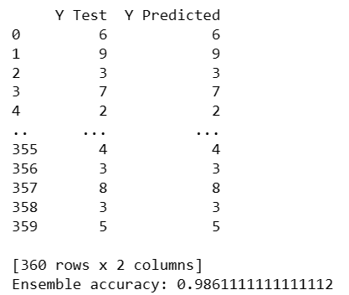

|  |  |  |
| --- | --- | --- |
| **Date** | **Lab No** | **Problem** |
| **04/04/2023** | **7** | To perform dimensionality reduction using Principal Component Analysis and infer the performance |

**Code:**

import numpy as np

import matplotlib.pyplot as plt

from sklearn import datasets

from sklearn.decomposition import PCA

from sklearn.ensemble import RandomForestClassifier

from sklearn.metrics import confusion_matrix

from sklearn.metrics import accuracy_score

from sklearn.preprocessing import StandardScaler

from sklearn.preprocessing import LabelEncoder

from sklearn.model_selection import train_test_split

# load iris dataset

df = datasets.load_digits()

x = df.data

y = df.target

le=LabelEncoder()

x_train,x_test,y_train,y_test=train_test_split(x,y,test_size=0.2,random_state=0)

sc=StandardScaler()

x_train=sc.fit_transform(x_train,y_train)

x_test=sc.transform(x_test)

# perform PCA

pca = PCA(n_components=4)

x_train = pca.fit_transform(x_train)

x_test=pca.transform(x_test)

explained_variance=pca.explained_variance_ratio_

print("Explained Variance Ratio: ",explained_variance)

classifier=RandomForestClassifier(max_depth=2,random_state=0)

classifier.fit(x_train,y_train)

y_pred=classifier.predict(x_test)

cm=confusion_matrix(y_pred,y_test)

print("Confusion Matrix: \n",cm)

print("Accuracy: ",accuracy_score(y_test,y_pred))

**Output:**

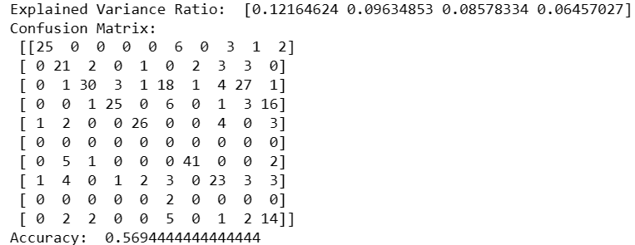

|  |  |  |
| --- | --- | --- |
| **Date** | **Lab No** | **Problem** |
| **04/04/2023** | **8** | To perform dimensionality reduction using Linear Discriminant Analysis and infer the performance |

**Code:**

import numpy as np

import pandas as pd

from sklearn import datasets

import matplotlib.pyplot as plt

from sklearn.ensemble import RandomForestClassifier

from sklearn.metrics import confusion_matrix,accuracy_score

# load iris dataset

df = datasets.load_breast_cancer()

x=df.data y=df.target

from sklearn.model_selection import train_test_split

x_train,x_test,y_train,y_test=train_test_split(x,y,test_size=0.2,random_state=0)

from sklearn.preprocessing import StandardScaler

sc=StandardScaler()

x_train=sc.fit_transform(x_train,y_train)

x_test=sc.transform(x_test)

class LDA:

def __init__(self, n_components=None):

self.n_components = n_components

self.eig_vectors = None

def transform(self,X,y):

height, width = X.shape

unique_classes = np.unique(y)

num_classes = len(unique_classes)

scatter_t = np.cov(X.T)*(height - 1)

scatter_w = 0

for i in range(num_classes):

class_items = np.flatnonzero(y == unique_classes[i])

scatter_w = scatter_w + np.cov(X[class_items].T) * (len(class_items)-1)

scatter_b = scatter_t - scatter_w

_, eig_vectors = np.linalg.eigh(np.linalg.pinv(scatter_w).dot(scatter_b))

print(eig_vectors.shape)

pc = X.dot(eig_vectors[:,::-1][:,:self.n_components]) print(pc.shape)

if self.n_components == 2:

if y is None:

plt.scatter(pc[:,0],pc[:,1])

else:

colors = ['r','g','b'], labels = np.unique(y)

for color, label in zip(colors, labels):

class_data = pc[np.flatnonzero(y==label)]

plt.scatter(class_data[:,0],class_data[:,1],c=color)

plt.show() return pc

LDA_obj = LDA(n_components=2)

LDA_object = LDA(n_components=2)

x_train_modified = LDA_object.transform(x_train, y_train)

x_test_modified = LDA_object.transform(x_test, y_test)

print("Original Data Size:",x_train.shape, "\nModified Data Size:", x_train_modified.shape) print(x_train_modified)

classifier=RandomForestClassifier(max_depth=2,random_state=0)

classifier.fit(x_train_modified,y_train)

y_pred=classifier.predict(x_test_modified)

cm=confusion_matrix(y_pred,y_test)

print("Confusion Matrix: \n",cm) print("Accuracy: ",accuracy_score(y_test,y_pred))

**Output:**

**Variation of Data:**

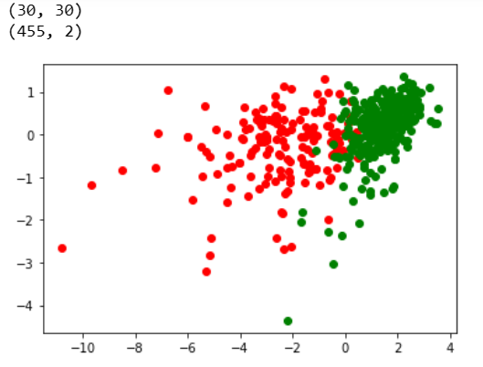

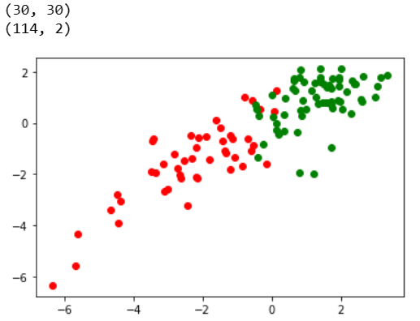

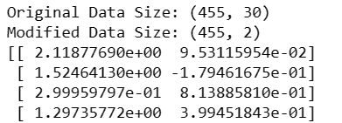

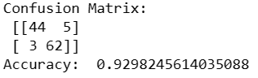

|  |  |  |
| --- | --- | --- |
| **Date** | **Lab No** | **Problem** |
| **04/04/2023** | **9** | To perform dimensionality reduction using Linear Discriminant Analysis and infer the performance |

**Code:**

import numpy as np

import matplotlib.pyplot as plt

from sklearn import datasets

from sklearn.decomposition import PCA

# load iris dataset

df = datasets.load_wine()

x = df.data

y = df.target

from sklearn.preprocessing import LabelEncoder

le=LabelEncoder()

from sklearn.model_selection import train_test_split

x_train,x_test,y_train,y_test=train_test_split(x,y,test_size=0.2,random_state=0)

from sklearn.preprocessing import StandardScaler

sc=StandardScaler()

x_train=sc.fit_transform(x_train,y_train)

x_test=sc.transform(x_test)

from sklearn.decomposition import TruncatedSVD

svd=TruncatedSVD(n_components=10,n_iter=10)

x_train=svd.fit_transform(x_train)

x_test=svd.transform(x_test)

explained_variance=svd.explained_variance_ratio_

print(explained_variance)

from sklearn.ensemble import RandomForestClassifier

classifier=RandomForestClassifier(max_depth=2,random_state=0)

classifier.fit(x_train,y_train)

y_pred=classifier.predict(x_test)

from sklearn.metrics import confusion_matrix

from sklearn.metrics import accuracy_score

cm=confusion_matrix(y_pred,y_test)

print(cm)

print(accuracy_score(y_test,y_pred))

**Output:**

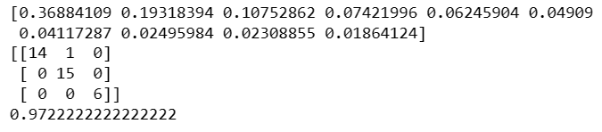

|  |  |  |
| --- | --- | --- |
| **Date** | **Lab No** | **Problem** |
| **11/04/2023** | **10** | To build an Artificial Neural Network that minimizes loss and maximizes the performance |

**Code:**

import pandas as pd

import numpy as np

import tensorflow as tf

from tensorflow import keras

from sklearn.model_selection import train_test_split

from keras.models import Sequential

from keras.layers import Dense

from tensorflow.keras.optimizers import Adam

# Load the data

df = pd.read_csv('https://archive.ics.uci.edu/ml/machine-learning-databases/breast-cancer-wisconsin/wdbc.data',header=None)

x=df.iloc[:,2:]

y=df.iloc[:,1]

y=np.where(y=='M',1,0)

X_train, X_test, y_train, y_test = train_test_split(x, y, test_size=0.2, random_state=0)

ann= Sequential()

ann.add(Dense(16, input_dim=X_train.shape[1], activation='relu'))

ann.add(Dense(8, activation='relu'))

ann.add(Dense(1, activation='sigmoid'))

# Compile the model

ann.compile(optimizer='adam',loss='binary_crossentropy', metrics=['accuracy'])

# Train the model

ann.fit(X_train, y_train, epochs=50, batch_size=100,verbose=0,validation_split=0.2)

# Evaluate the model

loss, accuracy =ann.evaluate(X_test, y_test)

print('Test accuracy:', accuracy)

ann_predict = ann.predict(X_test)

print("Prediction: ",np.round(ann_predict))

**Output:**

